SECTION FC

CAMSHAFT, CAM FOLLOWERS AND BEARINGS

CONTENTS

Chapter

Removal .. .. .. .. .. .. .. .. .. 1

Dismantling .. .. .. .. .. .. .. .. .. 2

Inspection .. .. .. .. .. .. .. .. .. 3

Assembly .. .. .. .. .. .. .. .. .. 4

Fitting.. .. .. .. .. .. .. .. .. .. 5

Special Tools.. .. .. .. .. .. .. .. .. 6

CHAPTER 1

REMOVAL

Component Removal

1. Remove air piping between turbocharger and charge air heater/cooler and between charge air heater/cooler and air inlet manifolds (Section LC).
2. Disconnect water washing piping from turbocharger.
3. Remove oil supply piping between free-end cover, turbocharger and fuel limiter.
4. Remove setscrews securing turbocharger oil drain to exhaust manifold (Section M).
5. Remove coolant inlet piping between exhaust manifold and turbocharger and between coolant pump outlet pipe and turbocharger.
6. Remove coolant outlet pipe between turbocharger and charge air heater/cooler support.
7. Release electrical supplies to the governor. Remove fuel injection pump transverse linkage (Section HC). Release nuts securing governor to mounting cover and lift off governor. Withdraw governor drive shaft.
8. Remove setscrews, bolts and nuts securing turbocharger to the exhaust manifold and lift off the turbocharger (Section M). Remove joint rings from exhaust ports and 'O' rings from coolant transfer ports.
9. Remove fuel supply and relief piping between reservoir and filter and reservoir and upper and lower fuel galleries.
10. Release setscrews securing the fuel reservoir to the charge air heater/cooler and remove the reservoir.
11. Remove coolant piping between charge air heater/cooler and oil cooler.
12. Remove bolts securing the charge air heater/cooler to its bracket and lift off the charge air heater/cooler.
13. Remove the coolant piping between the coolant circulating pump and coolant manifold portion of the fuel injection pump camboxes.
14. Remove the bolts securing the coolant thermostat to the coolant circulating pump and the charge air heater/ cooler bracket and remove the thermostat.
15. Remove the bolts securing the charge air heater/cooler bracket to the exhaust manifold and remove the bracket.

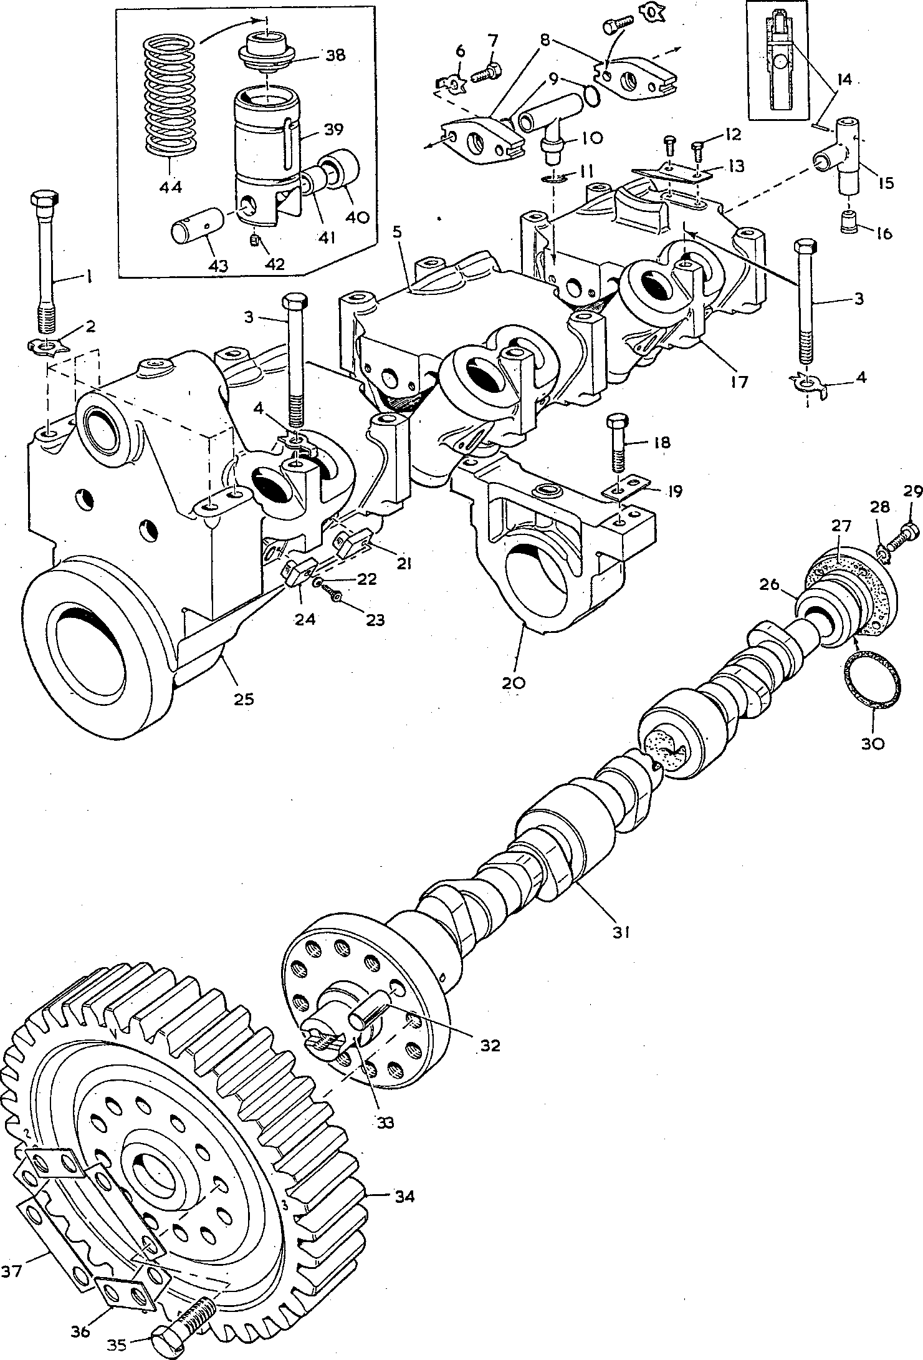

PD 870 5

Fig FC.l Engine camshaft, bearings and tappet housings

Key To Numbers

1. Waisted bolt
2. Tabwasher
3. Plain setbolt
4. Tabwasher
5. Intermediate tappet housing
6. Tabwasher
7. Setscrew
8. Oil connection flange
9. ’O’ rings, oil connections to flanges
10. Oil connection, between tappet housings and to camshaft intermediate bearing
11. 'O' ring, oil connection to intermediate camshaft bearing
12. Setscrew
13. Cardan shaft retaining plate
14. Mills pin
15. Free-end oil connection
16. Oil supply piston to coolant pump
17. Free-end tappet housing
18. Setbolt, intermediate camshaft bearing to crankcase
19. Locking plate
20. Intermediate camshaft bearing
21. Tappet guide peg, normal securing plate
22. Schnorr washer

23 Capscrew, tappet guide peg to housing

1. Tappet guide peg, short securing plate
2. Combined tappet housing, drive-end camshaft bearing and coolant pump drive housing
3. Free-end camshaft bearing
4. Joint, free-end camshaft bearing to crankcase
5. Tabwasher
6. Setscrew, free-end bearing to crankcase
7. 'O' ring for free-end camshaft bearing
8. Engine c amshaft
9. Dowel, drive gear to camshaft
10. Camshaft thrust collar
11. Drive gear
12. Bolt, drive gear to camshaft
13. Short locking plate
14. Long locking plate
15. Tappet push rod cup
16. Tappet body
17. Tappet roller
18. Roller bush
19. Grubscrew
20. Tappet roller pin
21. Tappet return spring

|  |  |  |
| --- | --- | --- |
| Key To Numbers |  |  |
| 17. Tappet housing | 40. | Tappet roller |
| 21. Tappet guide peg | 44. | Tappet return spring |
| 31. Engine camshaft | 45. | Jacking screw |
| 38. Push rod cup | 46. | Nut |
| 39. Tappet body | 47. | Washer |

Fig FC.2 Method of jacking tappets

45

46

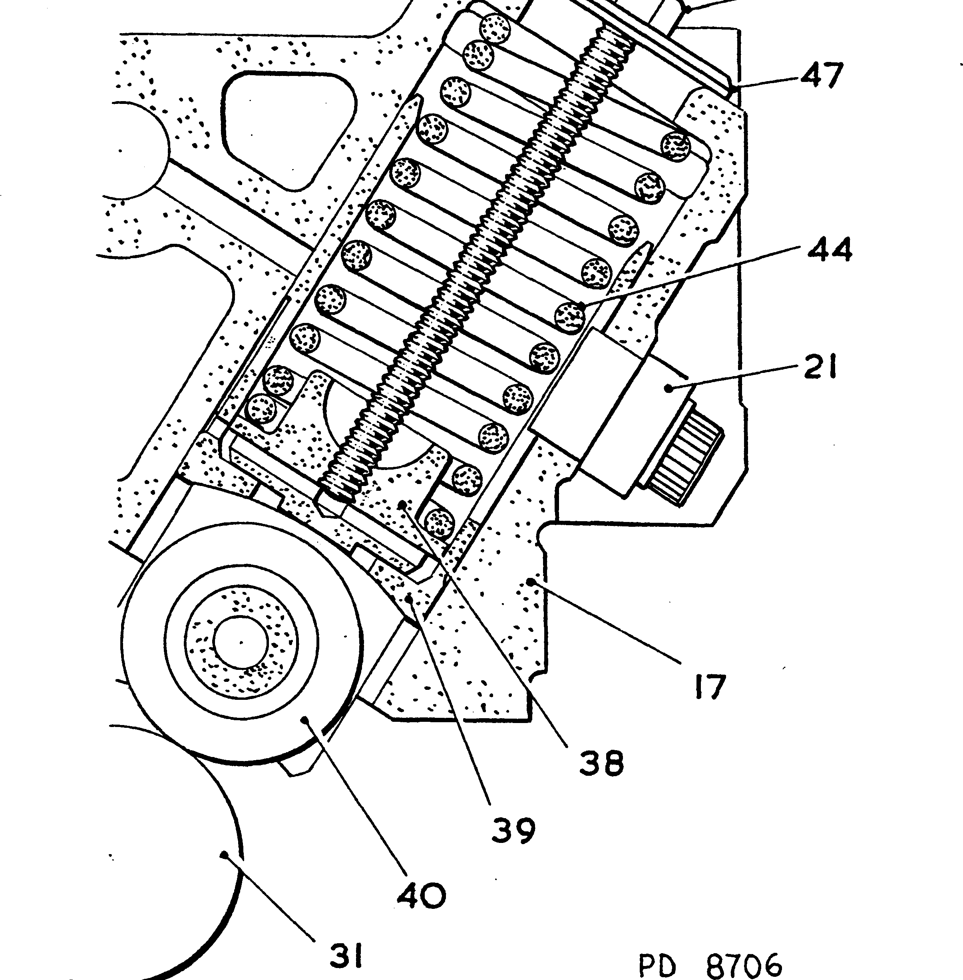

1. Remove the exhaust manifolds (Section LC)
2. Remove nuts and capscrews securing mounting cover to crankcase and setscrews securing mounting cover to cambox cover, and remove mounting cover.
3. Remove valve rocker gear and push rods (Section FA).
4. Release securing nuts and remove camtrough cover.
5. Release securing bolts and remove cambox stiffeners (Section FH).
6. Release securing nuts and remove coolant circulating pump. Remove coolant pump

cardan shaft.

1. Remove governor drive (Section FD).

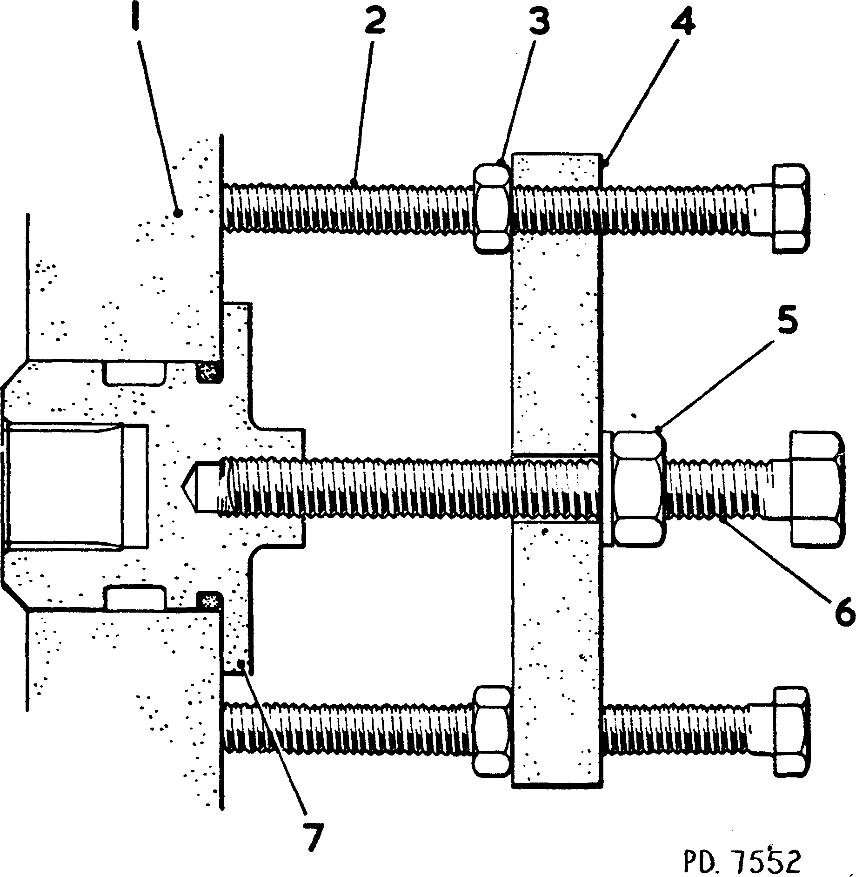

Key To Numbers

|  |  |  |  |
| --- | --- | --- | --- |
| 1. | Crankcase wall | 5. | Plain nut |
| 2. | Jacking screw | 6. | Centre screw |
| 3. | Locknut | 7. | Camshaft free-end bearing housing |
| 4. | Thrust plate |  |  |

Fig FC.3 Withdrawing free-end camshaft bearing Camshaft Removal

1. Bend back tabwashers (6)(Fig FC.l), release setscrews (7) and remove oil connections (10) complete with flanges (8) from between the tappet housings. Discard 'O' rings (9).

NOTE This instruction does not apply to free-end connection (15).

1. Fit nuts (46)(Fig FC.2) and washers (47) to jacking screws (45) and screw the jacking screws into the tapped holes in push rod cups (38) in the FREE-END tappet housing. Tighten the nut to draw the cup up the tappet bore, compressing spring (44) and taking the load off the camshaft. The spring should be compressed to solid length.
2. Bend back tabwashers (4)(Fig FC.l) and release setbolts (3) securing the INTERMEDIATE tappet housings (5). Lift the housings out of the camtrough.

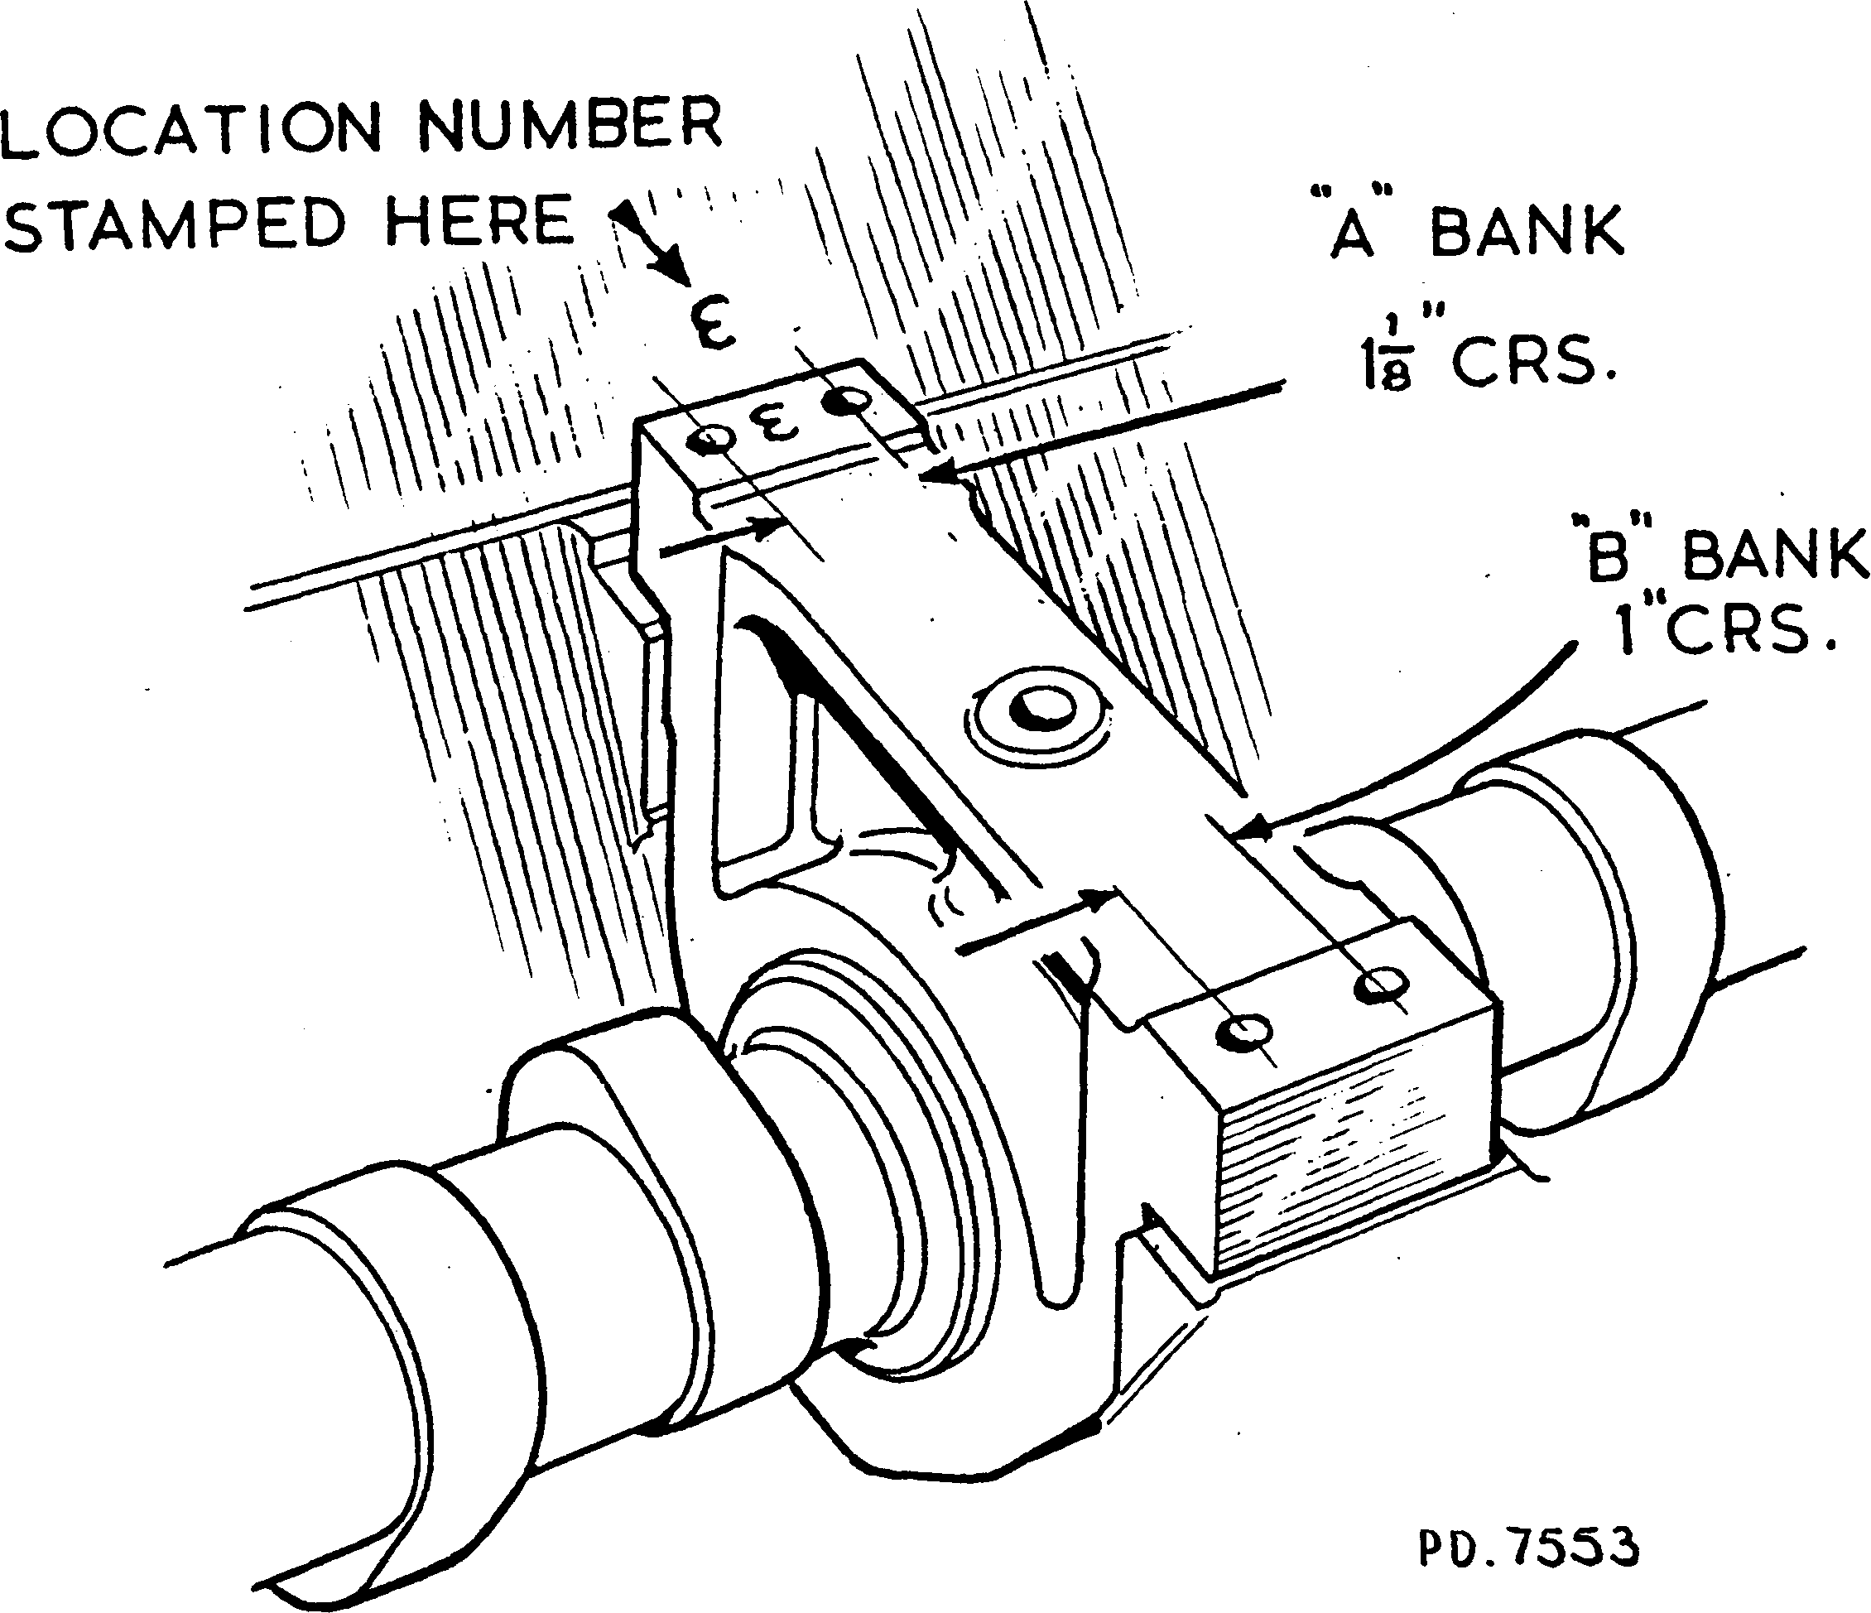

Fig FC.4 Marking of camshaft intermediate bearings

1. Bend back tabwashers (4) and release setbolts (3) securing free-end tappet housing
2. . Lift the housing complete with oil connection (15) from the camtrough. Remove the oil connection from the tappet housing.

NOTE The stem of the oil connection is a close fit in its bore in the crankcase and it may be necessary to assist its removal when lifting out the tappet housing. Access to the connection may be obtained through the coolant pump mounting aperture. Care must be taken not to damage or mark the aperture as this may affect sealing.

1. Remove jacking screws from the free-end tappet housing and fit to the DRIVE- END tappet housing, compressing the tappet springs as described in paragraph 1.24.
2. Bend back tabwashers and remove setscrews securing free-end camshaft bearing housing. Assemble bearing housing withdrawal tool (Fig FC.3) screwing centre screw (6) into bearing housing (7) and squaring thrust plate (4) to the crankcase by means of jacking screws (2). Tighten jacking screw locknuts (3). Withdraw the bearing housing by tightening nut (5).
3. Bend back tabwashers (2) and (4)(Fig FC.l) on drive-end housing (25) and locking plates (19) on intermediate bearings (20) and remove setbolts (1), (3) and (18). Check that the intermediate bearings are identified for position. The bearings are stamped on ’A’ bank side beneath the locking plates, with a corresponding number on the camtrough wall adjacent to the bearing (Fig FC.4). The bearings must be identified for position BEFORE the camshaft is removed.
4. Fit the camshaft bearing positioning tool (Fig FC.5). Check that capscrew heads (6) align with bearing housing oilways (7) and lock support bar (3) in position by means of T bolts (8).
5. Fit a suitable rope sling to the CAMSHAFT; DO NOT ATTEMPT TO LIFT BY MEANS OF THE POSITIONING TOOL. Lift the camshaft and bearings clear of the camtrough and place on a suitable support. During the initial lift it will be necessary to incline the camshaft, drive-end uppermost, to enable the drive-end bearing housing to clear the camtrough. Draw the complete assembly towards the drive-end of the engine to allow the free-end journal to clear the bearing housing bore in the crankcase.

NOTE When removing the engine camshaft from an engine with the fuel injection pumps and pump camboxes still fitted, it will be necessary to rotate the fuel injection pump camshafts by means of timing adjuster to allow the engine camshaft drive gear to be rolled out of engagement with the fuel injection pump idler gears (Section CC).

CHAPTER 2

DISMANTLING

Engine Camshaft (Fig FC.l)

1. Release and remove the crankshaft bearing positioning tool and allow all bearings to invert themselves.
2. Remove the bearings, drawing them off the free-end of the camshaft. When removing the drive-end bearing/tappet housing assembly, ensure that the tappet rollers do not strike the cams or journals.
3. Bend back locking plates (36) and (37), remove bolts (35) and draw gear (34) off the camshaft spigot and locating dowels (32). Remove camshaft thrust collar (33).

Tappet Housings (Fig FC.l)

1. Remove jacking screws from drive-end housing.
2. Invert housings, apply pressure to tappets, release capscrews (23) and remove schnorr washers (22) and guide pegs (21) and (24). Withdraw tappets complete with springs (44) from the housings.
3. Withdraw springs and push rod cups (38) from tappet bodies (39).
4. Remove grubscrews (42), press out pins (43) and withdraw rollers (40) and bushes (41) from the tappet bodies.

CHAPTER 3

INSPECTION

1. All dimensions should be checked, where possible, against those quoted in the Schedule of Clearances and Wear Tolerances (Section CD).
2. All components should be thoroughly cleaned in a non-caustic cleaning solution and the oilways flushed through.

Camshaft and Bearings

1. Examine the camshaft for general condition and evidence of wear and scoring. It will be found that the camshaft has a dark coating resulting from manufacturing treatment. NO ATTEMPT should be made to remove this coating.
2. Check the dimensions of both cams and journals.
3. Examine the bearing housings for general condition. Measure the bearing housing bores and check for scoring. Blend out any score marks with a scraper.
4. Examine the teeth of the drive gear for ridging, pitting or tearing. Carefully stone out any such marks.
5. Examine the flange of the thrust collar and the recess in the bore of the drive gear for scoring. Measure the thickness of the flange and the depth of the gear recess.

Cam Followers and Housings

1. Examine the cam follower bodies for general condition and scoring. Measure the diameter. Check that the oil holes in the bodies are clear. Examine guide peg slot for wear and scoring.
2. Examine the rollers, bushes and pins for wear and scoring. Measure the diameters and bores.
3. Examine the hardened push rod cups for wear and cracking. Check the return springs for distortion and collapse. Renew if necessary. Examine the housing bores for scoring and measure the bores. Check that the longitudinal and transverse oilways are clear. Check the guide pegs for wear and scoring.

General (Fig FC.l)

1. Check the condition of T shaped oil connections (10) and their mounting flanges.
2. Check that coolant pump oil supply piston (16) moves freely in oil connection (15). If any stickiness of movement is observed, withdraw retaining pin (14) and remove piston from connection. Examine both components for burrs and high spots and stone away any such marks. Re-assemble using a new pin; lock the pin by centre punching both ends.
3. Examine all studs, nuts, setscrews and bolts for serviceability.
4. Discard all 'O’ rings, joints, tabwashers and locking plates.

CHAPTER 4

ASSEMBLY

Tappet Housings (Fig FC.l)

1. Assemble bushes (41) and rollers (40) to tappet bodies (39), press pin (43) into position and fit grubscrew (42).

NOTE Ensure that pin (43) is correctly fitted and aligned to enable the point of grubscrew (42) to engage with the end drilling through the pin.

1. Insert cups (38) and springs (44) into the tappet bodies and fit to the tappet housings ensuring that the assemblies are returned to their original bores.

NOTE Guide peg (24) fitted to the drive-end tappet on the 'A' bank side has a shorter securing tab than the other pegs.

1. Invert the housings and align guide slots in the tappet bodies with the guide peg bores in the tappet housings. Depress tappet assemblies, fit guide pegs (21) and (24) and secure with capscrews (23) and schnorr washers (22). Torque load capscrews to 9 lbf/ft (12.20 Nm).
2. Fit cardan shaft retaining plate (13) to free-end housing (17) with setscrews (12), and bend up the corners of the plate to lock the setscrews.

Camshaft and Bearings (Fig FC.l)

1. Fit dowels (32) to the camshaft.
2. Insert thrust collar (33) into the recess in drive gear (34) and assemble the gear to the camshaft. One of the dowels is offset is to ensure correct location.
3. Fit securing bolts (35) and locking plates (36) and (37), fitting the long locking plates (37), over the dowels. Tighten the setscrews a little at a time to the torque loading quoted in Section CE, and bend up the locking plates.
4. Fit nuts (46)(Fig FC.2), washers (47) and jacking screws (45) to the drive-end tappet housing and compress springs (44) to solid length.
5. Thoroughly oil the drive-end camshaft journal, invert the drive-end tappet housing to allow the tappet rollers to move into the tappet bores and thread on the camshaft.
6. Oil the remaining camshaft journals and thread intermediate bearings (20) into position.

NOTE The intermediate bearings are not symmetrical. The two holding down bolts on the 'A ' bank side are at 1.125 in (28.57 mm) centres whilst those on the 'B' bank side are at 1 in (25.4 mm) centres. As stated in Chapter 1, Paragraph 1.29, the bearings are identified on the 'A' bank side, see Fig FC.4. Numbers read from the free-end of the camshaft.

Key To Numbers

1. 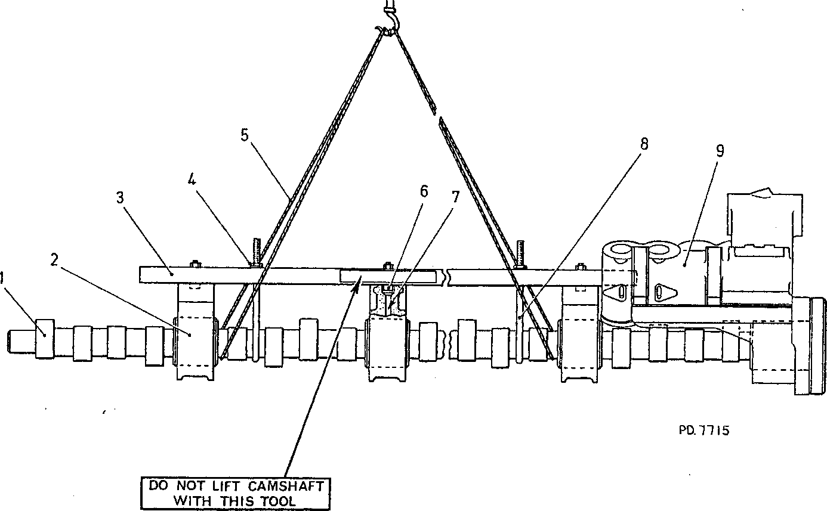Camshaft 6.

Capscrew

Bearing housing oilway T bolt

Drive-end camshaft

CHAPTER 5

FITTING

1. Intermediate camshaft bearing 7.

Support bar 8.

Adjusting nut 9.

Rope sling bearing

Fig FC.5 Positioning tool for camshaft bearings

Rotate the camshaft to place the 'V' mark on the gearwheel uppermost.

Fit the bearing positioning tool (Fig FC.5) and position 'J' bolts (8) by means of adjusting nuts (4) to lock the tool in position with the heads of capscrews (6) located in the bearing housing oil holes.

NOTE When fitting an engine camshaft to an engine with the fuel injection pumps and camboxes already fitted, it will be necessary to rotate the fuel pump camshafts by means of timing adjuster.

Fit a suitable rope sling to the camshaft, lift and fit to the engine. When fitting the camshaft it will be necessary to steady the drive-end housing by hand and to incline the camshaft, gear-end uppermost, to allow the free-end journal to enter the bearing housing bore in the crankcase before the remaining bearing housings engage with the machined locations in the camtrough. Ensure that the camshaft is correctly timed (Section CC).

LIMITED RIGHTS LEGEND

USE, DUPLICATION OR DISCLOSURE OP THIS INFORMATION WHICH IS THE PROPERTY OF GEC DIESELS LIMITED BY THE U.S. GOVERNMENT OR BOLLINGER IS SUBJECT TO THE RESTRICTIONS SET FORTH IN DOD FAR SUPP 252.227-7013 (a) IS.

Key To Numbers

1. Waisted bolts

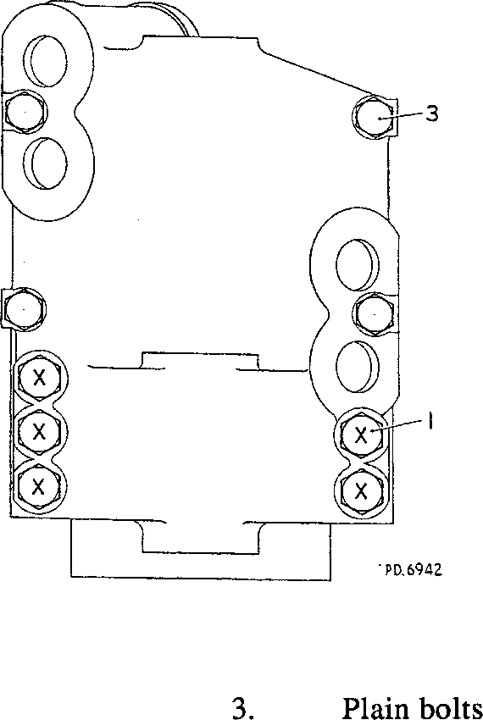Fig FC.6 Plan view of drive-end bearing housing showing bolt positions

1. Remove lifting sling and bearing positioning tool.

NOTE The five special waisted bolts (1) (Figs FC.l and FC.6) are tightened to a higher torque loading than bolts (3).

5.5. Referring to Fig FC.6 for bolt positions, secure the drive-end bearing with five off special waisted bolts (1) and tabwashers and four off bolts (3) and tabwashers. Tighten the bolts to the torque loading quoted in Section CE and bend up tabwashers.

NOTE The locking plates for 'B' bank side have holes at 1 in (25.4 mm) centres, whilst those for 'A' bank side have holes at 1.125 in (28.5 mm) centres.

1. Secure intermediate bearings (20)(Fig FC.l) with setbolts (18) and locking plates
2. . Tighten the bolts to the torque loading quoted in Section CE and bend up locking plates.
3. Fit a new joint (27) and 'O' ring (30) to free-end bearing housing (26), insert the housing into the free-end of the crankcase and secure with setscrews (29) and tabwashers (28). Refer to Section CE for the correct torque loading. Bend up tabwashers.

5.8. Remove the tappet jacking screws from the combined drive-end camshaft bearing/tappet housing and fit to the free-end tappet housing (17).

1. Fit oil connection (15) to the free-end tappet housing.
2. Fit the free-end tappet housing (17) and, working through the coolant pump aperture, guide the stem of oil connection (15) into its bore in the crankcase.
3. Fit intermediate tappet housings (5).
4. Fit bolts (3) and tabwashers (4) to all housings, tighten to the torque loading quoted in Section CE and bend up tabwashers.
5. Remove tappet jacking screws from the free-end tappet housing.
6. Fit new 'O' rings (11) to the shouldered stems of tee-pieces (10). Fit new 'O’ rings
7. to the grooves in the bores of flanges (8), insert setscrews (7) with tabwashers
8. through the flanges and slide the flanges onto the legs of the tee-pieces.
9. Locate the shouldered stem of the tee-pieces in the counter bores in the tops of the camshaft bearings and secure the flanges to the tappet housings with the setscrews. Bend up tabwashers.
10. Complete reassembly of the engine using new joints and 'O' rings throughout.

CHAPTER 6

SPECIAL TOOLS

The following special tools are sufficient for carrying out all general maintenance, dismantling, overhaul and assembly operations on the camshaft, bearings and tappet housings as detailed in this section. Standard workshop tools are not included.

NOTE These tools are only shown in the Illustrated Parts List if they if they have been ordered as part of the contract.

|  |  |  |
| --- | --- | --- |
| DESCRIPTION | PART NO | USE |
| Torque wrench 10 to 50 lb ft  1/2 in square drive | OD26977 | To tighten the camshaft bearing setscrews and tappet housing setbolts to a pre-determined loading |
| Torque wrench 50 to 250 lb ft  1/2 in square drive | OD28465 | To tighten the drive-end camshaft bearing waisted bolt and camshaft drive gear bolts to a pre-determined loading |
| Drive extension 1/2 in square drive | ST038053 | To extend reach of torque wrench into camtrough |
| Free-end bearing extractor | Y3J70908 | To withdraw free-end camshaft bearing from crankcase |
| Tappet jacking screws | Y3J70833 | Used with nuts and washers to compress tappet return springs |
| Bearing positioning tool | 16Y3J70709B | To maintain position and alignment of intermediate camshaft bearings when removing or fitting camshaft |
| Injection pump camshaft adjusting tool | Y3J70005C | To rotate the fuel injection pump camshaft and idler gear wheels when removing and fitting the engine camshaft with the fuel pump camboxes fitted |